Bibliobus U.P.
Search results for "DiCaprio, Leonardo"

 | Author / Title | Year | Support / Genre | Notice nr.
 | Tarantino, Quentin  Once upon a time in... Hollywood | 2019 | DVD  Dramatic comedy | 775613
 | Gonzalez Inarritu, Alejandro  The revenant | 2016 | DVD  Western | 774280
 | Luhrmann, Baz  Gatsby le magnifique | 2013 | DVD  Drama | 773316
 | Nolan, Christopher  Inception | 2013 | DVD  Science-fiction | 774147
 | Scorsese, Martin  Le loup de Wall street | 2013 | DVD  Drama | 773813
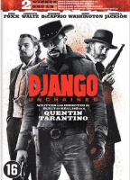 | Tarantino, Quentin  Django unchained | 2013 | DVD  Western | 772998
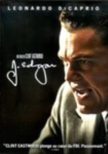 | Eastwood, Clint  J. Edgar | 2012 | DVD  Biography | 772731
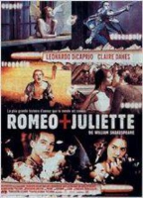 | Luhrmann, Baz  Romeo + Juliette | 2012 | DVD  Dramatic comedy | 773277
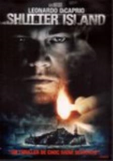 | Scorsese, Martin  Shutter Island | 2010 | DVD  Thriller | 772169
 | Mendes, Sam  Les noces rebelles | 2009 | DVD  Drama | 771949
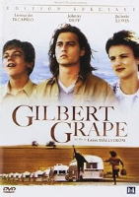 | Hallström, Lasse  Gilbert Grape | 2007 | DVD  Dramatic comedy | 773723
 | Scorsese, Martin  Les infiltrés | 2007 | DVD  Crime fiction | 771758
 | Scorsese, Martin  The aviator | 2005 | DVD  Biography | 771065
 | Spielberg, Steven  Arrête-moi si tu peux | 2003 | DVD  Thriller | 770204
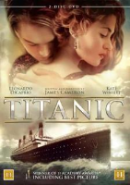 | Cameron, James  Titanic | 1997 | DVD  Drama | 775437

