Bibliobus U.P.
Search results for "SENEGAL (CINEMA)"

 | Author / Title | Year | Support / Genre | Notice nr.
 | Diop, Mati  Atlantique | 2020 | DVD  Drama | 775611
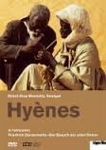 | Diop-Mambety, Djibril  Hyènes | 2013 | DVD  Dramatic comedy | 773168
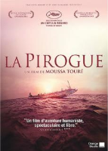 | Touré, Moussa  La pirogue | 2013 | DVD  Drama | 773007
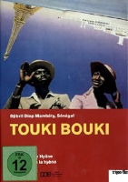 | Diop-Mambety, Djibril  Le voyage de la hyène Touki Bouki | 2012 | DVD  Dramatic comedy | 773174
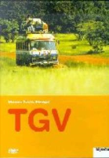 | Touré, Moussa  TGV | 2005 | DVD  Comedy | 772888
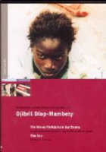 | Diop-Mambety, Djibril  La petite vendeuse de soleil; Le franc | 2004 | DVD  Dramatic comedy | 770680
 | Wade, Mansour Sora  Le prix du pardon | 2003 | DVD  Dramatic comedy | 771690

