Bibliobus U.P.
Search results for "Ventura, Lino"

 | Author / Title | Year | Support / Genre | Notice nr.
 | Verneuil, Henri  Cent mille dollars au soleil | 2012 | DVD  Adventure | 773149
 | Lautner, Georges  Les tontons flingueurs | 2005 | DVD  Comedy | 771042
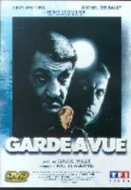 | Miller, Claude  Garde à vue | 2000 | DVD  Crime fiction | 770447

