Bibliobus U.P.
Search results for "Penn, Sean"

 | Author / Title | Year | Support / Genre | Notice nr.
 | Anderson, Paul Thomas  Licorice pizza | 2022 | DVD  Dramatic comedy | 776360
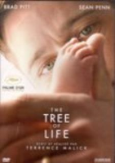 | Malick, Terrence  The tree of life | 2011 | DVD  Fantastic | 772513
 | Sorrentino, Paolo  This must be the place | 2011 | DVD  Drama | 772746
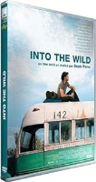 | Penn, Sean  Into the wild | 2008 | DVD  Adventure | 776609
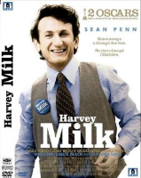 | Van Sant, Gus  Harvey Milk | 2008 | DVD  Biography | 774880
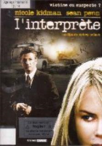 | Pollack, Sydney  L'interprète | 2005 | DVD  Thriller | 771028
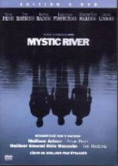 | Eastwood, Clint  Mystic river | 2004 | DVD  Crime fiction | 770818
 | Malick, Terrence  La ligne rouge | 2003 | DVD  History | 770585
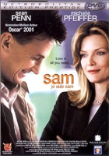 | Nelson, Jessie  Sam, je suis Sam | 2001 | DVD  Drama | 776214

