Bibliobus U.P.
Search results for "Hunger, Sophie"

 | Author / Title | Year | Support / Genre | Notice nr.
 | Hunger, Sophie  Halluzinationen | 2020 | CD  Songs | 705622
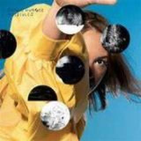 | Hunger, Sophie  Molecules | 2018 | CD  Songs | 705399
 | Barras, Claude  Ma vie de Courgette | 2016 | DVD | 774561
 | Hunger, Sophie  The danger of light | 2012 | CD  Songs | 704539
 | Lewinsky, Micha  Der Freund | 2008 | DVD  Dramatic comedy | 771671

