Bibliobus U.P.
Search results for "International movies"

 | Author / Title | Year | Support / Genre | Notice nr.
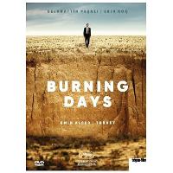 | Alper, Emin  Burning days | 2022 | DVD  Thriller | 776557
 | Guzman, Patricio  Mi pais imaginario = Mon pays imaginaire | 2022 | DVD | 776509
 | Li Ruijun  Le retour des hirondelles = Return to dust | 2022 | DVD  Drama | 776575
 | Loayza Grisi, Alejandro  Utama : la terre oubliée | 2022 | DVD  Drama | 776446
 | Dorji, Pawo Choyning  Lunana, l'école du bout du monde | 2021 | DVD  Drama | 776060
 | Touzani, Maryam  Adam | 2019 | DVD  Drama | 775730
 | Kubat, Aktan Arym  Centaur | 2017 | DVD  Drama | 774800
 | Sadat, Shahrbanoo  Wolf and sheep | 2017 | DVD  Drama | 774689
 | Guerra, Ciro  L'étreinte du serpent | 2016 | DVD  Drama | 774260
 | Ozu, Yasujiro  Fin d'automne | 2016 | DVD  Drama | 774478
 | Jaugey, Florence  La yuma | 2011 | DVD  Drama | 772575
 | Michel, Thierry  Katanga business | 2009 | DVD | 773176

